

## AMITY INSTITUTE OF IFORMATION TECHNOLOGY AMITY UNIVERSITY

**PATNA– 801503**

**Session 2023-27**

# Hospital Patient Analytics System: Predictive Analytics for Healthcare Resource Planning and Disease Pattern Analysis

*Synopsis submitted in partial fulfilment of the requirements for the award of the Degree of the Summer Internship Report*

# BACHELOR OF COMPUTER APPLICATION

Submitted by

# Ridhi Kumari (A45304823082)

# Nidhi kumari (A45304823083)

Under the Supervision of

## [Internal Guide: Abhinav sahay] [External Guide: srijan kumar]

**Assistant professor,AIIT trainer, KW**

Table of Content

## AMITY INSTITUTE OF IFORMATION TECHNOLOGY

1. Hospital Patient Analytics System
2. INTRODUCTION AND OBJECTIVES OF THE PROJECT
3. SCOPE OF THE PROJECT
4. SYSTEM ANALYSIS
5. COMPLETE STRUCTURE
6. TOOLS/PLATFORM AND REQUIREMENTS
7. WORK PLAN / GANTT CHART
8. EXPECTED OUTCOMES
9. REFERENCES / BIBLIOGRAPHY
10. ORGANIZATION/COMPANY DETAILS

3. INTRODUCTION AND OBJECTIVES OF THE PROJECT

3.1 Introduction

Healthcare systems worldwide face increasing pressure to optimize resource allocation, predict patient influx, and improve operational efficiency. The Hospital Patient Analytics System is designed to analyze historical patient admission data, identify patterns in disease prevalence, and predict future admission trends to support strategic healthcare planning.

The system leverages machine learning algorithms and statistical analysis to process large datasets from hospital admissions, mortality records, and environmental factors to provide actionable insights for healthcare administrators.

3.2 Objectives

Primary Objectives:

1. Analyze admission rates by age groups and disease categories

2. Predict busy periods for hospitals using time series forecasting

3. Identify common diseases by geographical regions

4. Provide interactive dashboards for real-time analytics

Secondary Objectives:

1. Implement risk factor analysis for patient outcomes

2. Develop correlation analysis between environmental factors and health patterns

3. Generate automated reports for hospital management

4. Create predictive models for capacity planning

4. SCOPE OF THE PROJECT

4.1 Boundaries

Included:

- Patient admission data analysis (age, disease, temporal patterns)

- Predictive modeling for admission forecasting

- Interactive visualization dashboard

- Statistical analysis of disease prevalence

- Environmental factor correlation analysis

- Report generation system

Not Included:

- Real-time patient monitoring systems

- Electronic Health Record (EHR) integration

- Patient privacy-sensitive data processing

- Clinical decision support systems

- Billing or financial analysis

4.2 Limitations

- Analysis limited to historical data patterns

- Predictions based on available dataset features

- No real-time data streaming capabilities

- Limited to structured data formats (CSV, JSON)

5. SYSTEM ANALYSIS

5.1 Level 0 DFD (Context Diagram)

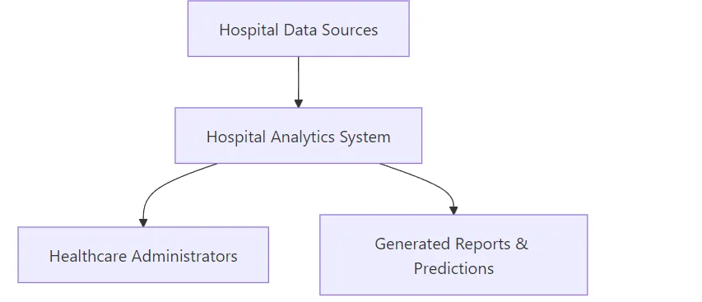

5.2 Level 1 DFD (Process Decomposition)

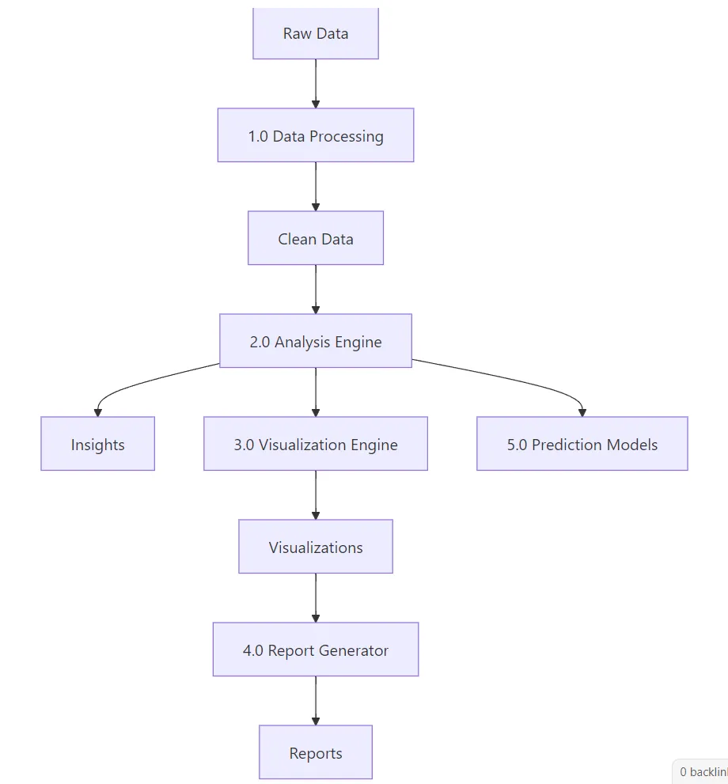

5.3 Entity Relationship Diagram

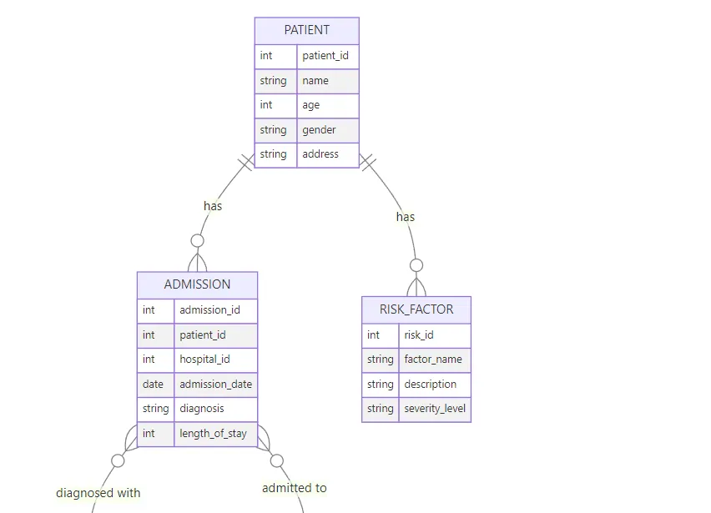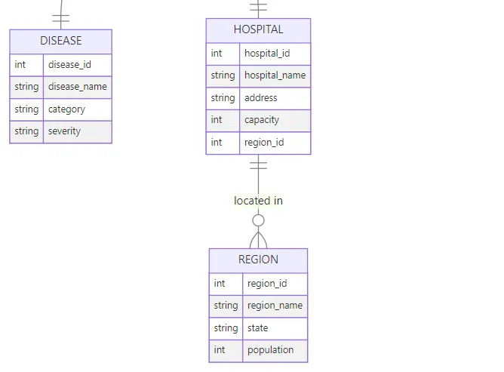

5.4 Class Diagram (Key Classes)

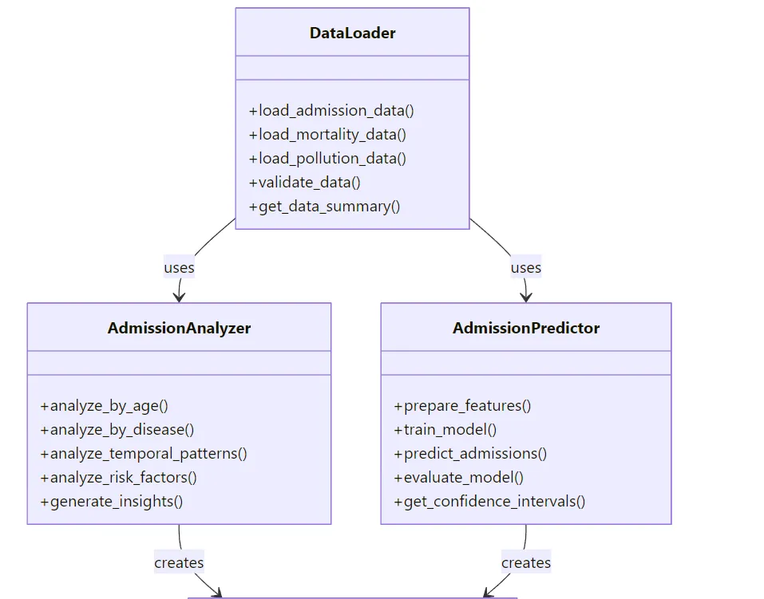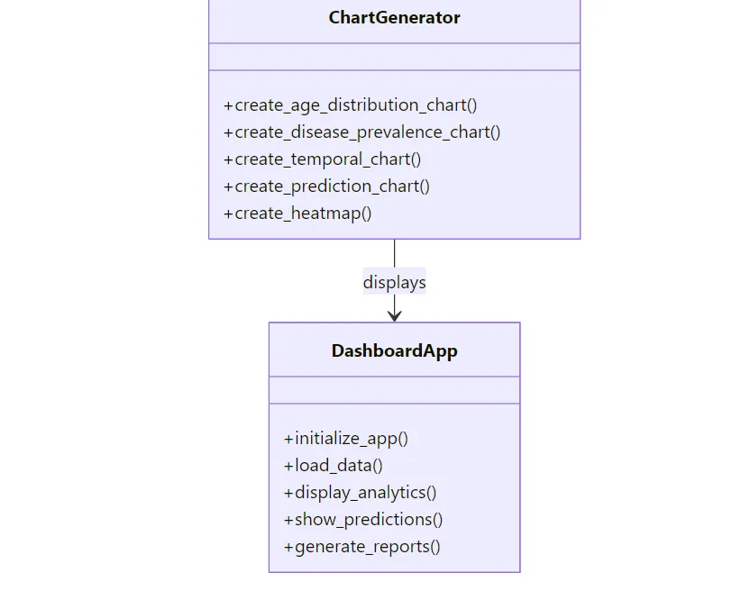

6. COMPLETE STRUCTURE

6.1 Module Description

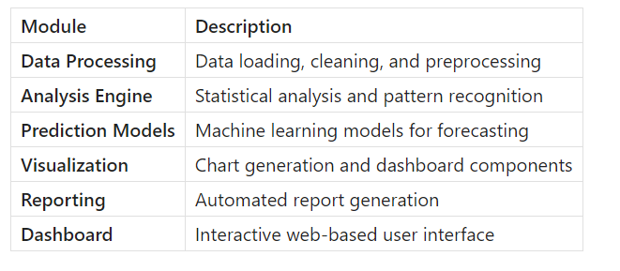

6.2 Database/Data Structures

Primary Data Structures:

- Admission Records: Patient ID, Date, Age, Disease codes, Hospital ID

- Mortality Data: Patient outcomes and risk factors

- Environmental Data: Pollution levels, seasonal factors

- Hospital Metadata: Location, capacity, specializations

Data Formats:

- Input: CSV files with structured healthcare data

- Processing: Pandas DataFrames

- Output: JSON reports, PNG/HTML visualizations

6.3 Process Logic Flow Charts

Data Processing Flow: Analysis Flow: Prediction Flow:

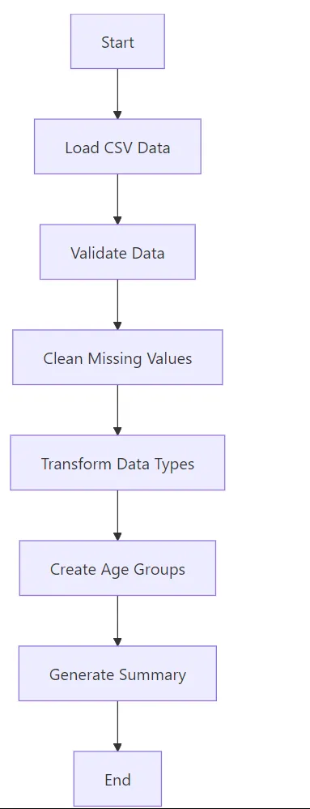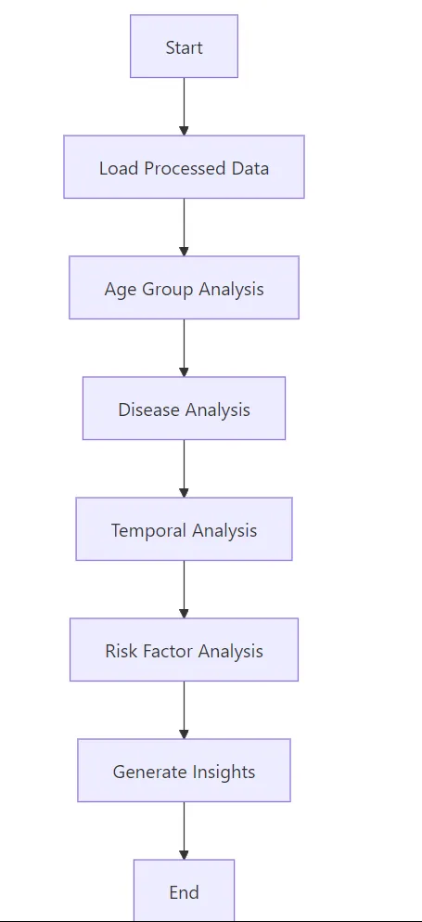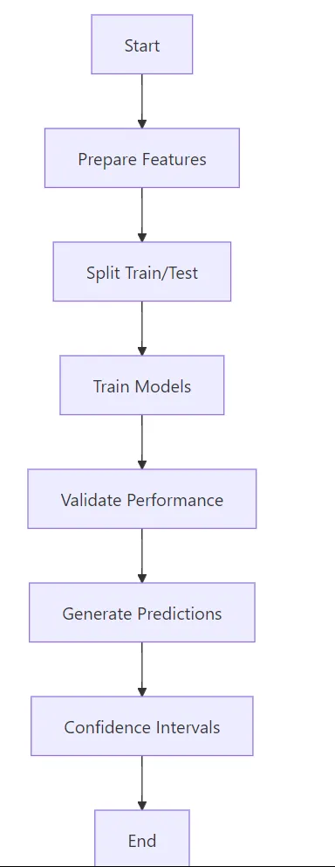6.4 Report Formats

Generated Reports:

1. Executive Summary: Key metrics and trends (PDF)

2. Detailed Analytics: Comprehensive analysis (HTML)

3. Prediction Report: Forecasting results (JSON/PDF)

4. Visual Dashboard: Interactive charts (Web Interface)

7. TOOLS/PLATFORM AND REQUIREMENTS

7.1 Software Requirements

- Programming Language: Python 3.8+

- Web Framework: Streamlit

- Data Analysis: Pandas, NumPy

- Machine Learning: Scikit-learn

- Visualization: Plotly, Matplotlib

- Development Environment: VS Code/PyCharm

7.2 Hardware Requirements

- Minimum: 8GB RAM, Intel i5 processor, 10GB storage

- Recommended: 16GB RAM, Intel i7 processor, 50GB storage

7.3 Platform Requirements

- Operating System: Windows 10+, macOS 10.15+, Linux Ubuntu 18+

- Web Browser: Chrome, Firefox, Edge (latest versions)

8. WORK PLAN / GANTT CHART

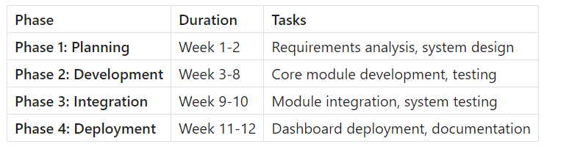

Timeline Visualization:

Week 1-2: [████████████████████] Planning & Design

Week 3-4: [████████████████████] Data Processing

Week 5-6: [████████████████████] Analysis & ML

Week 7-8: [████████████████████] Visualization

Week 9-10: [████████████████████] Integration

Week 11-12:[████████████████████] Deployment

9. EXPECTED OUTCOMES

9.1 Deliverables

1. Functional System: Complete analytics platform

2. Interactive Dashboard: Web-based user interface

3. Prediction Models: Trained ML models for forecasting

4. Documentation: Technical and user manuals

5. Test Reports: System validation results

9.2 Benefits

For Hospitals:

- Improved resource allocation

- Better capacity planning

- Data-driven decision making

- Cost optimization

For Healthcare System:

- Pattern identification in disease outbreaks

- Regional health trend analysis

- Preventive care planning

- Research insights

10. REFERENCES / BIBLIOGRAPHY

1. Healthcare Analytics:

- Raghupathi, W., & Raghupathi, V. (2014). "Big data analytics in healthcare"

- Kumar, S., et al. (2018). "Machine Learning in Healthcare Analytics"

2. Technical Resources:

- McKinney, W. (2017). "Python for Data Analysis" - O'Reilly Media

- VanderPlas, J. (2016). "Python Data Science Handbook" - O'Reilly Media

3. Online Resources:

- World Health Organization (WHO) Data Repository

- Kaggle Healthcare Datasets

- Python Documentation (python.org)

- Streamlit Documentation (streamlit.io)

11. ORGANIZATION/COMPANY DETAILS

11.1 Academic Institution

[Amity institute of information technology, Amity University Patna]

- Department: Computer Science/Information Technology

- Address: [Amity University Patna near rupaspur police station bailey road Patna 801503]

- Contact: [+91 9117506246]

Project Duration: 12 weeks | Team Size: 1-2 developers |